Cross Validation Comparison

# Training Results Comparison

**Mean AUC-ROC (Training)**

|  |  |  |  |  |  |  |
| --- | --- | --- | --- | --- | --- | --- |
| Classifier | Feature 5 | Feature 8 | Feature 16 | Feature 22 | Feature 27 | Feature 30 |
| KNN | 0.91 | 0.98 | 1.00 | 1.00 | 1.00 | 1.00 |
| Random Forest | 1.00 | 1.00 | 1.00 | 1.00 | 1.00 | 1.00 |
| XGBoost | 0.78 | 0.86 | 0.95 | 0.97 | 0.98 | 0.98 |
| Decision Tree | 1.00 | 1.00 | 1.00 | 1.00 | 1.00 | 1.00 |
| Extra Trees | 1.00 | 1.00 | 1.00 | 1.00 | 1.00 | 1.00 |

**Mean Accuracy (Training)**

|  |  |  |  |  |  |  |
| --- | --- | --- | --- | --- | --- | --- |
| Classifier | Feature 5 | Feature 8 | Feature 16 | Feature 22 | Feature 27 | All Features |
| KNN | 0.91 | 0.98 | 1.00 | 1.00 | 1.00 | 1.00 |
| Random Forest | 1.00 | 1.00 | 1.00 | 1.00 | 1.00 | 1.00 |
| XGBoost | 0.78 | 0.86 | 0.95 | 0.97 | 0.98 | 0.98 |
| Decision Tree | 1.00 | 1.00 | 1.00 | 1.00 | 1.00 | 1.00 |
| Extra Trees | 1.00 | 1.00 | 1.00 | 1.00 | 1.00 | 1.00 |

**Mean F1-Score (Training)**

|  |  |  |  |  |  |  |
| --- | --- | --- | --- | --- | --- | --- |
| Classifier | Feature 5 | Feature 8 | Feature 16 | Feature 22 | Feature 27 | All Features |
| KNN | 0.91 | 0.98 | 1.00 | 1.00 | 1.00 | 1.00 |
| Random Forest | 1.00 | 1.00 | 1.00 | 1.00 | 1.00 | 1.00 |
| XGBoost | 0.77 | 0.86 | 0.95 | 0.97 | 0.98 | 0.98 |
| Decision Tree | 1.00 | 1.00 | 1.00 | 1.00 | 1.00 | 1.00 |
| Extra Trees | 1.00 | 1.00 | 1.00 | 1.00 | 1.00 | 1.00 |

# Test Result Comparison

**Mean AUC-ROC (Test)**

|  |  |  |  |  |  |  |
| --- | --- | --- | --- | --- | --- | --- |
| Classifier | Feature 5 | Feature 8 | Feature 16 | Feature 22 | Feature 27 | All Features |
| KNN | 0.84 | 0.95 | 0.99 | 1.00 | 1.00 | 1.00 |
| Random Forest | 0.83 | 0.93 | 0.98 | 0.99 | 0.99 | 0.99 |
| XGBoost | 0.72 | 0.82 | 0.92 | 0.95 | 0.96 | 0.96 |
| Decision Tree | 0.74 | 0.84 | 0.90 | 0.91 | 0.91 | 0.91 |
| Extra Trees | 0.83 | 0.94 | 0.99 | 0.99 | 0.99 | 0.99 |

**Mean Accuracy (Test)**

|  |  |  |  |  |  |  |
| --- | --- | --- | --- | --- | --- | --- |
| Classifier | Feature 5 | Feature 8 | Feature 16 | Feature 22 | Feature 27 | All Features |
| KNN | 0.84 | 0.95 | 0.99 | 1.00 | 1.00 | 1.00 |
| Random Forest | 0.83 | 0.93 | 0.98 | 0.99 | 0.99 | 0.99 |
| XGBoost | 0.72 | 0.82 | 0.92 | 0.95 | 0.95 | 0.96 |
| Decision Tree | 0.74 | 0.84 | 0.90 | 0.91 | 0.91 | 0.91 |
| Extra Trees | 0.83 | 0.94 | 0.99 | 0.99 | 0.99 | 0.99 |

**Mean F1 Score (Test)**

|  |  |  |  |  |  |  |
| --- | --- | --- | --- | --- | --- | --- |
| Classifier | Feature 5 | Feature 8 | Feature 16 | Feature 22 | Feature 27 | All Features |
| KNN | 0.84 | 0.95 | 0.99 | 1.00 | 1.00 | 1.00 |
| Random Forest | 0.83 | 0.93 | 0.98 | 0.99 | 0.99 | 0.99 |
| XGBoost | 0.72 | 0.81 | 0.92 | 0.94 | 0.95 | 0.96 |
| Decision Tree | 0.74 | 0.84 | 0.90 | 0.91 | 0.91 | 0.91 |
| Extra Trees | 0.83 | 0.93 | 0.99 | 0.99 | 0.99 | 0.99 |

# Deep Learning

**Artificial Neural Network Architecture**

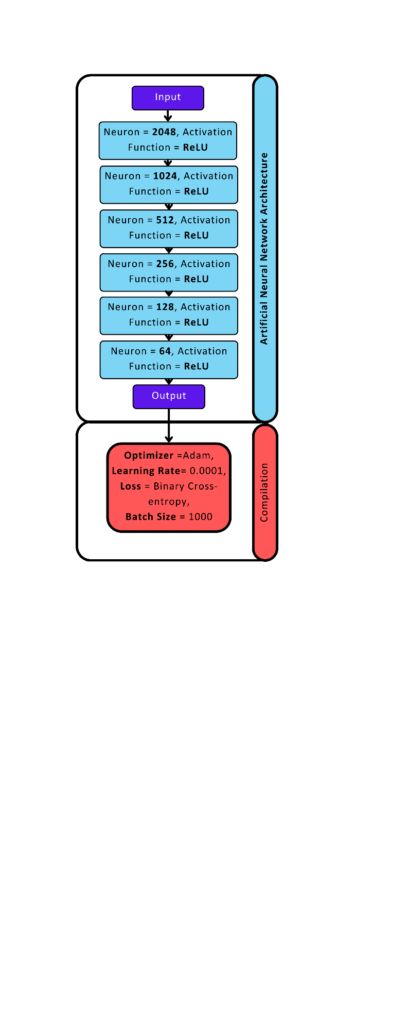

**Long short-term memory Architecture**

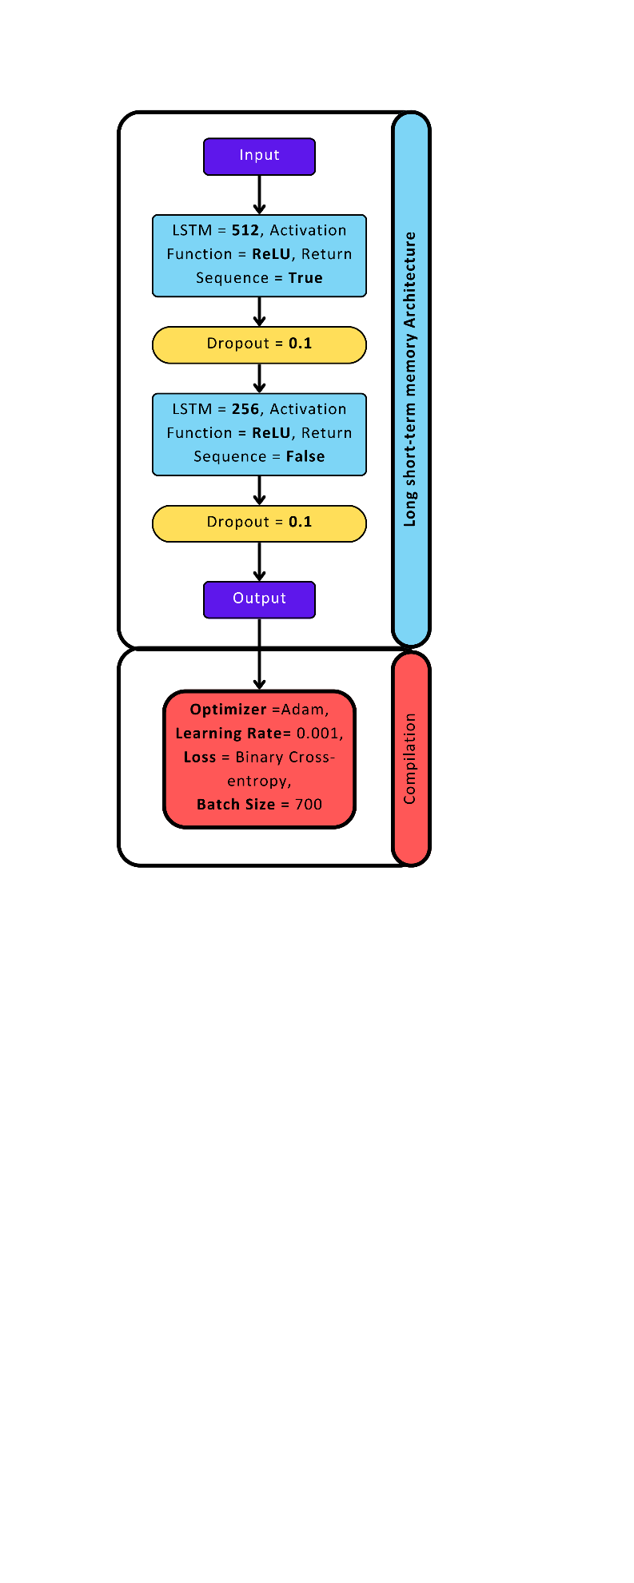

**Gated Recurrent Unit Networks**

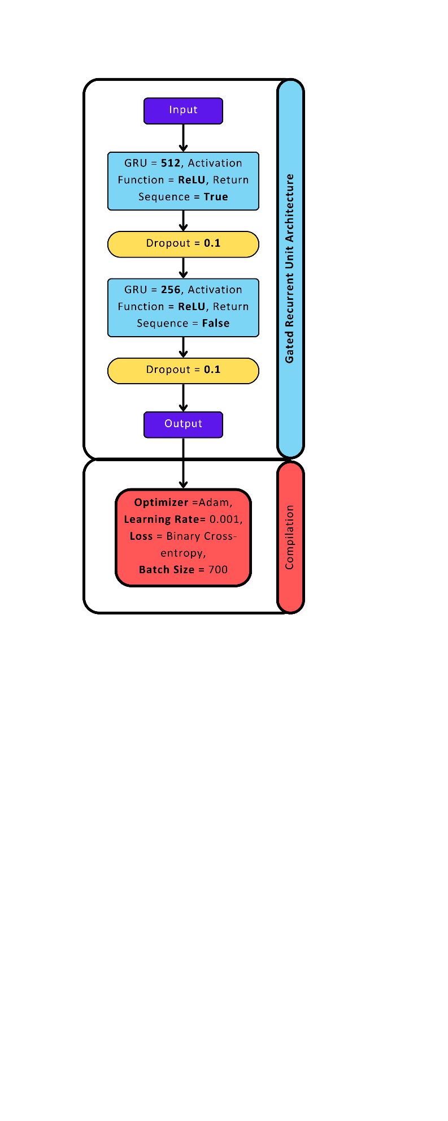

**Ensemble Learning**

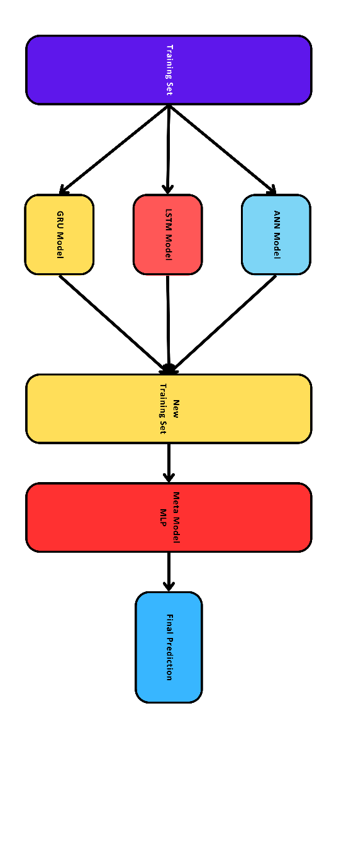

## Deep Learning Results Comparison

|  |  |  |  |  |
| --- | --- | --- | --- | --- |
| Metric | ANN | GRU | LSTM | Meta Learning |
| Accuracy | 0.8722 | 0.8776 | 0.8836 | 0.9021 |
| Precision | 0.8631 | 0.8820 | 0.8946 | 0.9089 |
| Recall | 0.8846 | 0.8716 | 0.8695 | 0.8937 |
| F1-score | 0.8737 | 0.8768 | 0.8819 | 0.9012 |

## Performance Comparison Using 5 Features

|  |  |  |
| --- | --- | --- |
| Model | Accuracy | F1 Score |
| XGBoost | 0.72 | 0.72 |
| Decision Tree | 0.74 | 0.74 |
| Random Forest | 0.83 | 0.83 |
| Extra Trees | 0.83 | 0.83 |
| KNN | 0.84 | 0.84 |
| ANN | 0.87 | 0.87 |
| GRU | 0.88 | 0.88 |
| LSTM | 0.88 | 0.88 |
| Meta Learning | 0.90 | 0.90 |